**МИНИСТЕРСТВО НАУКИ И ВЫСШЕГО**

**ОБРАЗОВАНИЯ РОССИЙСКОЙ ФЕДЕРАЦИИ**ФЕДЕРАЛЬНОЕ ГОСУДАРСТВЕННОЕ БЮДЖЕТНОЕ ОБРАЗОВАТЕЛЬНОЕ УЧРЕЖДЕНИЕ  
ВЫСШЕГО ОБРАЗОВАНИЯ  
**«БЕЛГОРОДСКИЙ ГОСУДАРСТВЕННЫЙ  
ТЕХНОЛОГИЧЕСКИЙ УНИВЕРСИТЕТ им. В.Г.ШУХОВА»  
(БГТУ им. В.Г.Шухова)**

Кафедра программного обеспечения вычислительной техники и автоматизированных систем

Лабораторная работа №5

Дисциплина: Теория цифровых автоматов

по теме Синтез и анализ многовыходных комбинационных

схем в базисе И-ИЛИ-НЕ

Выполнил: ст. группы ВТ-31  
Новожен Н.В

Проверил: Рязанов.Ю.Д

**Белгород 2019**

**Цель работы**: научиться строить эффективные по быстродействию и затратам оборудования многовыходные комбинационные схемы.

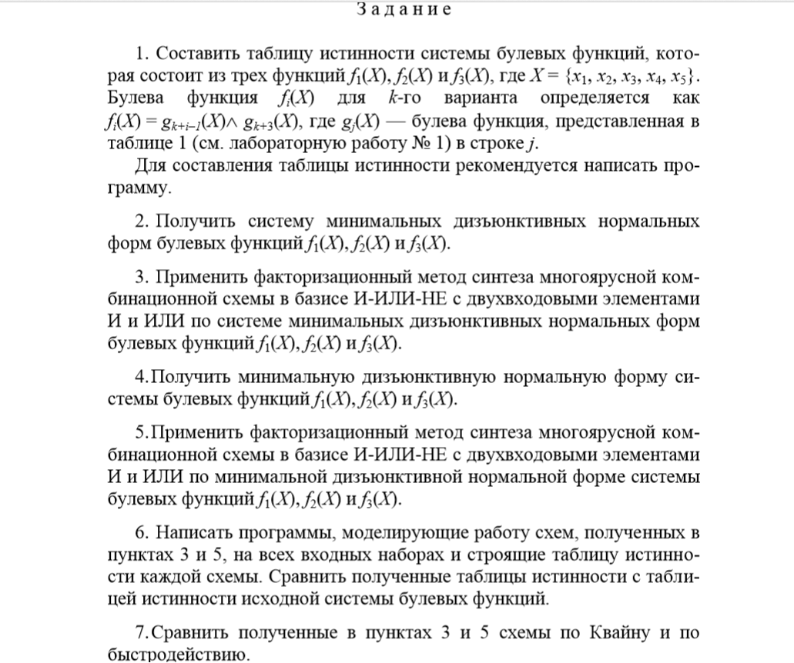

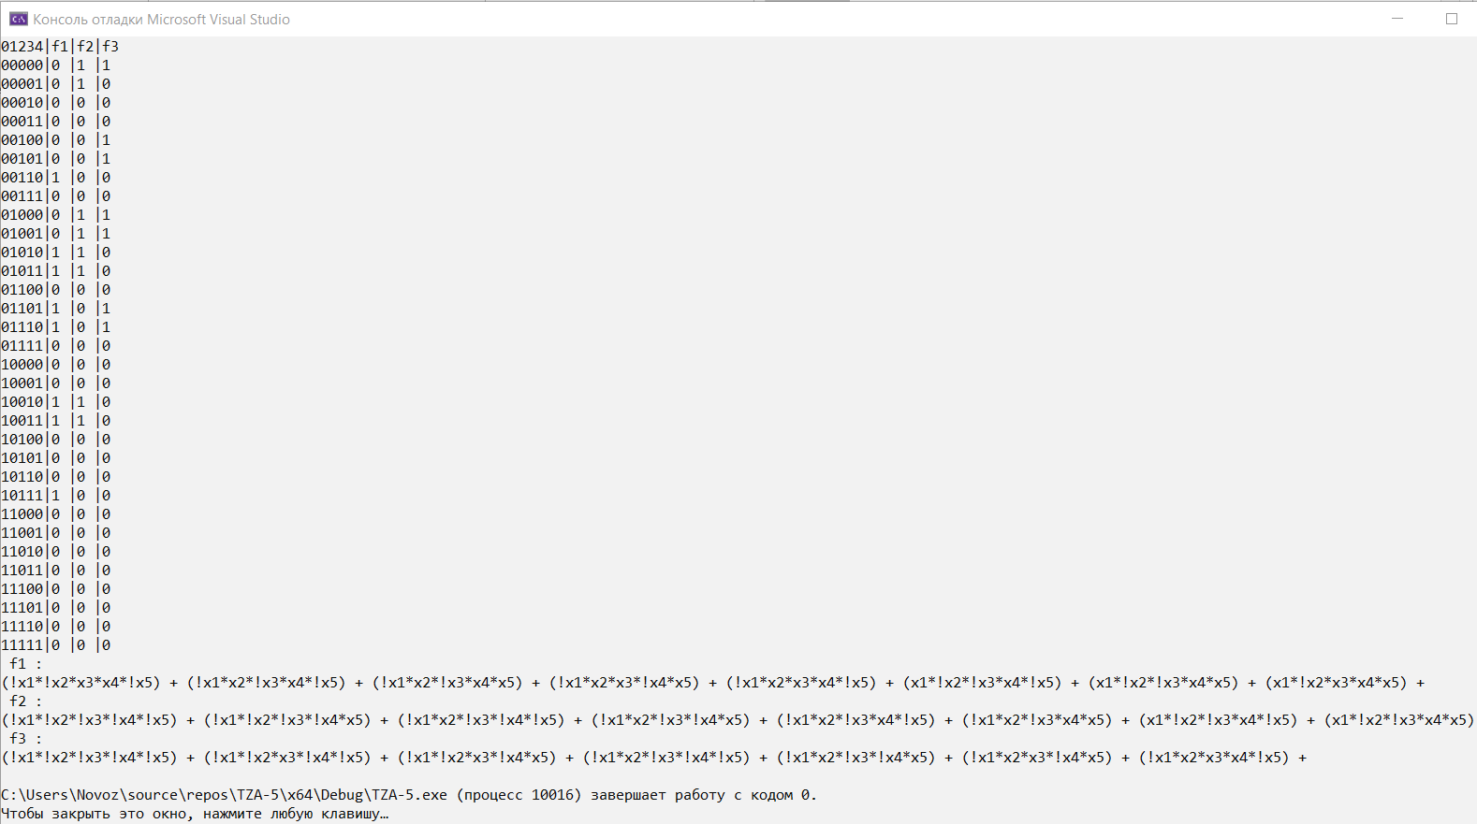

01234|f1|f2|f3

00000|0 |1 |1

00001|0 |1 |0

00010|0 |0 |0

00011|0 |0 |0

00100|0 |0 |1

00101|0 |0 |1

00110|1 |0 |0

00111|0 |0 |0

01000|0 |1 |1

01001|0 |1 |1

01010|1 |1 |0

01011|1 |1 |0

01100|0 |0 |0

01101|1 |0 |1

01110|1 |0 |1

01111|0 |0 |0

10000|0 |0 |0

10001|0 |0 |0

10010|1 |1 |0

10011|1 |1 |0

10100|0 |0 |0

10101|0 |0 |0

10110|0 |0 |0

10111|1 |0 |0

11000|0 |0 |0

11001|0 |0 |0

11010|0 |0 |0

11011|0 |0 |0

11100|0 |0 |0

11101|0 |0 |0

11110|0 |0 |0

11111|0 |0 |0

f1 : 00110 01010 01011 01101 01110 10010 10011 10111

(!x1*!x2*x3*x4*!x5) + (!x1*x2*!x3*x4*!x5) + (!x1*x2*!x3*x4*x5) + (!x1*x2*x3*!x4*x5) + (!x1*x2*x3*x4*!x5) + (x1*!x2*!x3*x4*!x5) + (x1*!x2*!x3*x4*x5) + (x1*!x2*x3*x4*x5)

f2 : 00000 00001 01000 01001 01010 01011 10010 10011

(!x1*!x2*!x3*!x4*!x5) + (!x1*!x2*!x3*!x4*x5) + (!x1*x2*!x3*!x4*!x5) + (!x1*x2*!x3*!x4*x5) + (!x1*x2*!x3*x4*!x5) + (!x1*x2*!x3*x4*x5) + (x1*!x2*!x3*x4*!x5) + (x1*!x2*!x3*x4*x5)

f3 : 00000 00100 00101 01000 01001 01101 01110

(!x1*!x2*!x3*!x4*!x5) + (!x1*!x2*x3*!x4*!x5) + (!x1*!x2*x3*!x4*x5) + (!x1*x2*!x3*!x4*!x5) + (!x1*x2*!x3*!x4*x5) + (!x1*x2*x3*!x4*x5) + (!x1*x2*x3*x4*!x5)

**2.**

f1 : 00110 01010 01011 01101 01110 10010 10011 10111

|  |  |  |
| --- | --- | --- |
| 2 | 3 | 4 |
| 10010 *  01010 *  00110 * | 10011 *  01110 *  01101  01011 * | 10111 * |
| 1001-  01-10  0-110  0101- | 10-11 |

|  |  |  |  |  |  |  |  |  |  |
| --- | --- | --- | --- | --- | --- | --- | --- | --- | --- |
|  | **\*** | **\*** | **\*** | **\*** | **\*** | **\*** | **\*** | **\*** |  |
|  | **00110** | **01010** | **01011** | **01101** | **01110** | **10010** | **10011** | **10111** |  |
| **01101** |  |  |  | **+** |  |  |  |  | **-** |
| **10-11** |  |  |  |  |  |  | **+** | **+** | **-** |
| **1001-** |  |  |  |  |  | **+** | **+** |  | **-** |
| **01-10** |  | **+** |  |  | **+** |  |  |  |  |
| **0-110** | **+** |  |  |  | **+** |  |  |  | **-** |
| **0101-** |  | **+** | **+** |  |  |  |  |  | **-** |
|  |  |  |  |  |  |  |  |  |  |

МДНФ: 

f2 : 00000 00001 01000 01001 01010 01011 10010 10011

|  |  |  |  |
| --- | --- | --- | --- |
| 0 | 1 | 2 | 3 |
| 00000 * | 00001 *  01000 * | 01001 *  01010 *  10010 * | 01011 *  10011 * |
| 0000- *  0-000 * | 0-001 *  0100- *  101-0 * | 010-1 *  0101- *  1001- |  |
| 0-00- | 010-- |  |  |

|  |  |  |  |  |  |  |  |  |  |
| --- | --- | --- | --- | --- | --- | --- | --- | --- | --- |
|  | **\*** | **\*** | **\*** | **\*** | **\*** | **\*** | **\*** | **\*** |  |
|  | **00000** | **00001** | **01000** | **01001** | **01010** | **01011** | **10010** | **10011** |  |
| **1001-** |  |  |  |  |  |  | **+** | **+** | **-** |
| **0-00-** | **+** | **+** | **+** | **+** |  |  |  |  | **-** |
| **010--** |  |  | **+** | **+** | **+** | **+** |  |  | **-** |
|  |  |  |  |  |  |  |  |  |  |

МДНФ: 

f3 : 00000 00100 00101 01000 01001 01101 01110

|  |  |  |  |
| --- | --- | --- | --- |
| 0 | 1 | 2 | 3 |
| 00000 * | 00100 *  01000 * | 00101 *  01001 * | 01101 *  01110 |
| 00-00  0-000 | 0010-  0100- | 0-101  01-01 |  |

|  |  |  |  |  |  |  |  |  |
| --- | --- | --- | --- | --- | --- | --- | --- | --- |
|  | **\*** | **+** | **+** | **\*** | **\*** | **\*** | **\*** |  |
|  | **00000** | **00100** | **00101** | **01000** | **01001** | **01101** | **01110** |  |
| **01110** |  |  |  |  |  |  | **+** | **-** |
| **00-00** | **+** | **+** |  |  |  |  |  |  |
| **0-000** | **+** |  |  | **+** |  |  |  | **-** |
| **0010-** |  | **+** | **+** |  |  |  |  | **-** |
| **0100-** |  |  |  | **+** | **+** |  |  |  |
| **0-101** |  |  | **+** |  |  | **+** |  |  |
| **01-01** |  |  |  |  | **+** | **+** |  | **-** |

Ядро Квайна: **01110**

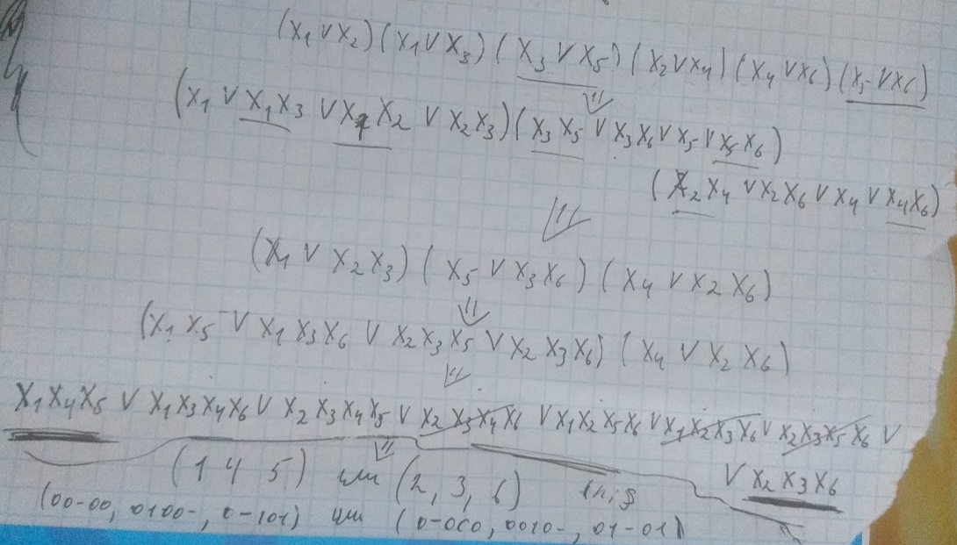

МДНФ: 

**3**

|  |  |  |  |  |  |  |  |  |  |  |  |  |  |  |  |  |  |  |  |  |  |  |  |  |  |
| --- | --- | --- | --- | --- | --- | --- | --- | --- | --- | --- | --- | --- | --- | --- | --- | --- | --- | --- | --- | --- | --- | --- | --- | --- | --- |
|  | **x1** | **!x1** | **x2** | **!x2** | **x3** | **!x3** | **x4** | **!x4** | **x5** | **!x5** | **z1** | **z2** | **z3** | **z4** | **z5** | **z6** | **z7** | **z8** | **z9** | **z10** | **z11** | **z12** | **z13** | **h1** | **h2** |
| **u1** | **~~1~~** |  |  | **~~1~~** |  | **~~1~~** | **~~1~~** |  |  |  | **1** |  |  |  | **1** |  |  |  |  |  |  |  |  |  |  |
| **u2** | **~~1~~** |  |  | **~~1~~** |  |  | **~~1~~** |  | **~~1~~** |  | **1** |  |  |  |  | **1** |  |  |  |  |  |  |  |  |  |
| **u3** |  | **~~1~~** | **~~1~~** |  |  | **~~1~~** | **~~1~~** |  |  |  |  | **1** | **1** |  |  |  |  |  |  |  |  |  |  |  |  |
| **u4** |  | **~~1~~** |  |  | **~~1~~** |  | **~~1~~** |  |  | **~~1~~** |  | **1** |  | **1** |  |  |  |  |  |  |  |  |  |  |  |
| **u5** |  | **~~1~~** | **~~1~~** |  | **~~1~~** |  |  | **~~1~~** | **~~1~~** |  |  |  |  |  |  |  | **~~1~~** | **1** |  |  |  |  |  | **1** |  |
| **u6** |  | **~~1~~** |  |  |  | **~~1~~** |  | **~~1~~** |  | **~~1~~** |  |  |  |  |  |  |  |  | **1** | **1** |  |  |  |  |  |
| **u7** |  | **~~1~~** | **~~1~~** |  |  |  |  | **~~1~~** | **~~1~~** |  |  |  |  |  |  |  | **1** |  |  |  | **1** |  |  |  |  |
| **u8** |  | **~~1~~** |  | **~~1~~** | **~~1~~** |  |  | **~~1~~** |  |  |  |  |  |  |  |  |  | **1** |  |  |  | **1** |  |  |  |
| **u9** |  | **~~1~~** | **~~1~~** |  | **~~1~~** |  | **~~1~~** |  |  | **~~1~~** |  |  |  | **~~1~~** |  |  |  |  |  |  |  |  | **1** |  | **1** |
| **u10** |  | **~~1~~** |  |  |  | **~~1~~** |  | **1** |  |  |  |  |  |  |  |  |  |  | **1** |  |  |  |  |  |  |
| **u11** |  | **1** | **~~1~~** |  |  | **~~1~~** |  |  |  |  |  |  | **1** |  |  |  |  |  |  |  |  |  |  |  |  |
| **z1** | **1** |  |  | **1** |  |  |  |  |  |  |  |  |  |  |  |  |  |  |  |  |  |  |  |  |  |
| **z2** |  | **1** |  |  |  |  | **1** |  |  |  |  |  |  |  |  |  |  |  |  |  |  |  |  |  |  |
| **z3** |  |  | **1** |  |  | **1** |  |  |  |  |  |  |  |  |  |  |  |  |  |  |  |  |  |  |  |
| **z4** |  |  |  |  | **1** |  |  |  |  | **1** |  |  |  |  |  |  |  |  |  |  |  |  |  |  |  |
| **z5** |  |  |  |  |  | **1** | **1** |  |  |  |  |  |  |  |  |  |  |  |  |  |  |  |  |  |  |
| **z6** |  |  |  |  |  |  | **1** |  | **1** |  |  |  |  |  |  |  |  |  |  |  |  |  |  |  |  |
| **z7** |  | **1** | **1** |  |  |  |  |  |  |  |  |  |  |  |  |  |  |  |  |  |  |  |  |  |  |
| **z8** |  |  |  |  | **1** |  |  | **1** |  |  |  |  |  |  |  |  |  |  |  |  |  |  |  |  |  |
| **z9** |  | **1** |  |  |  | **1** |  |  |  |  |  |  |  |  |  |  |  |  |  |  |  |  |  |  |  |
| **z10** |  |  |  |  |  |  |  | **1** |  | **1** |  |  |  |  |  |  |  |  |  |  |  |  |  |  |  |
| **z11** |  |  |  |  |  |  |  | **1** | **1** |  |  |  |  |  |  |  |  |  |  |  |  |  |  |  |  |
| **z12** |  | **1** |  | **1** |  |  |  |  |  |  |  |  |  |  |  |  |  |  |  |  |  |  |  |  |  |
| **z13** |  | **1** | **1** |  |  |  |  |  |  |  |  |  |  |  |  |  |  |  |  |  |  |  |  |  |  |
| **h1** |  |  |  |  |  |  |  |  | **1** |  |  |  |  |  |  |  | **1** |  |  |  |  |  |  |  |  |
| **h2** |  |  |  |  |  |  | **1** |  |  |  |  |  |  | **1** |  |  |  |  |  |  |  |  |  |  |  |

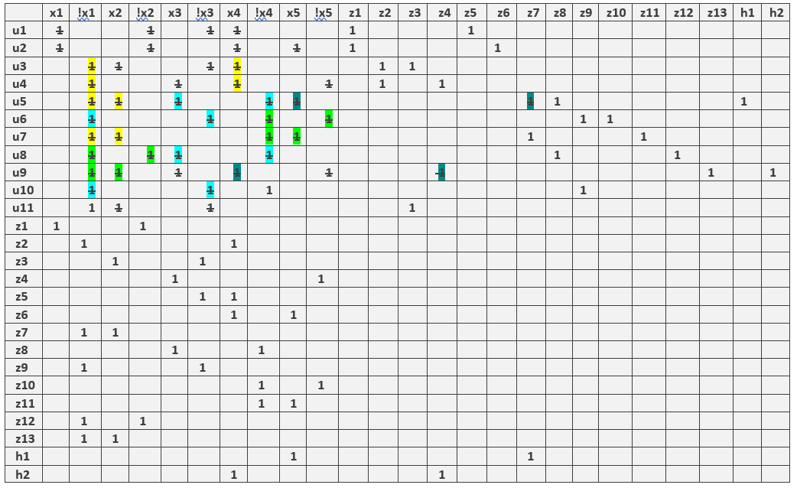

|  |  |  |  |  |  |  |  |  |  |  |  |  |  |  |  |  |  |
| --- | --- | --- | --- | --- | --- | --- | --- | --- | --- | --- | --- | --- | --- | --- | --- | --- | --- |
|  | **u1** | **u2** | **u3** | **u4** | **u5** | **u6** | **u7** | **u8** | **u9** | **u10** | **u11** | **V1** | **V2** | **V3** | **V4** | **v5** | **g1** |
| **Y1** | **~~1~~** | **~~1~~** | **~~1~~** | **~~1~~** | **~~1~~** |  |  |  |  |  |  | **~~1~~** | **1** |  |  |  | **1** |
| **Y2** |  |  |  |  |  | **~~1~~** | **~~1~~** | **~~1~~** | **~~1~~** |  |  |  |  | **1** | **1** |  |  |
| **Y3** | **1** |  |  |  |  |  |  |  |  | **~~1~~** | **~~1~~** |  |  |  |  | **1** |  |
| **V1** | **1** | **1** |  |  |  |  |  |  |  |  |  |  |  |  |  |  |  |
| **V2** |  |  | **~~1~~** | **1** |  |  |  |  |  |  |  |  |  |  |  |  |  |
| **V3** |  |  |  |  |  | **1** | **1** |  |  |  |  |  |  |  |  |  |  |
| **V4** |  |  |  |  |  |  |  | **1** | **1** |  |  |  |  |  |  |  |  |
| **V5** |  |  |  |  |  |  |  |  |  | **1** | **1** |  |  |  |  |  |  |
| **G1** |  |  |  |  | **1** |  |  |  |  |  |  | **1** |  |  |  |  |  |



**4**

f1 = (!x1 && x3 && x4 && !x5) || (!x1 && x2 && !x3 && x4) || (!x1 && x2 && x3 && !x4 && x5) || (x1 && !x2 && !x3 && x4) || (x1 && !x2 && x4 && x5);

f2 = (!x1 && x2 && !x3 && x4) || (x1 && !x2 && !x3 && x4) || (!x1 && !x3 && !x4);

f3 = (!x1 && x3 && x4 && !x5) || (!x1 && x2 && x3 && !x4 && x5) || (!x1 && !x2 && x3 && !x4) || (!x1 && !x3 && !x4);

|  |  |  |  |  |  |  |  |  |  |  |  |  |  |  |  |  |  |  |  |  |  |  |  |  |  |
| --- | --- | --- | --- | --- | --- | --- | --- | --- | --- | --- | --- | --- | --- | --- | --- | --- | --- | --- | --- | --- | --- | --- | --- | --- | --- |
|  | **x1** | **!x1** | **x2** | **!x2** | **x3** | **!x3** | **x4** | **!x4** | **x5** | **!x5** | **z1** | **z2** | **z3** | **z4** | **z5** | **z6** | **z7** | **z8** | **z9** | **z10** | **z11** | **h1** | **h2** | **z12** | **z13** |
| **u1** |  | **1** |  |  | **1** |  | **1** |  |  | **1** | **1** |  |  |  |  | **1** |  |  |  |  |  |  |  |  |  |
| **u2** |  | **1** | **1** |  |  | **1** | **1** |  |  |  | **1** |  |  |  | **1** |  |  |  |  |  |  |  |  |  |  |
| **u3** |  | **1** | **1** |  | **1** |  |  | **1** | **1** |  |  | **1** |  |  |  |  | **1** |  |  |  |  | **1** |  |  |  |
| **u4** | **1** |  |  | **1** |  | **1** | **1** |  |  |  |  |  | **1** |  |  |  |  | **1** |  |  |  |  |  |  |  |
| **u5** | **1** |  |  | **1** |  |  | **1** |  | **1** |  |  |  | **1** |  |  |  |  |  | **1** |  |  |  |  |  |  |
| **u6** |  | **1** | **1** |  | **1** |  | **1** |  |  | **1** |  | **1** |  |  |  |  |  |  |  | **1** |  |  | **1** |  |  |
| **u7** |  | **1** |  | **1** | **1** |  |  | **1** |  |  |  |  |  | **1** |  |  |  |  |  |  | **1** |  |  |  |  |
| **u8** |  | **1** | **1** |  |  | **1** |  | **1** |  |  |  |  |  | **1** | **1** |  |  |  |  |  |  |  |  |  |  |
| **u9** |  | **1** |  |  |  | **1** |  | **1** |  |  |  |  |  |  |  |  |  |  |  |  |  |  |  | **1** |  |
| **u10** |  | **1** |  | **1** |  |  |  | **1** |  | **1** |  |  |  |  |  |  |  |  |  |  |  |  |  | **1** | **1** |
| **z1** |  | **1** |  |  |  |  | **1** |  |  |  |  |  |  |  |  |  |  |  |  |  |  |  |  |  |  |
| **z2** |  | **1** |  |  | **1** |  |  |  |  |  |  |  |  |  |  |  |  |  |  |  |  |  |  |  |  |
| **z3** | **1** |  |  | **1** |  |  |  |  |  |  |  |  |  |  |  |  |  |  |  |  |  |  |  |  |  |
| **z4** |  | **1** |  |  |  |  |  | **1** |  |  |  |  |  |  |  |  |  |  |  |  |  |  |  |  |  |
| **z5** |  |  | **1** |  |  | **1** |  |  |  |  |  |  |  |  |  |  |  |  |  |  |  |  |  |  |  |
| **z6** |  |  |  |  | **1** |  |  |  |  | **1** |  |  |  |  |  |  |  |  |  |  |  |  |  |  |  |
| **z7** |  |  | **1** |  |  |  |  | **1** |  |  |  |  |  |  |  |  |  |  |  |  |  |  |  |  |  |
| **z8** |  |  |  |  |  | **1** | **1** |  |  |  |  |  |  |  |  |  |  |  |  |  |  |  |  |  |  |
| **z9** |  |  |  |  |  |  | **1** |  | **1** |  |  |  |  |  |  |  |  |  |  |  |  |  |  |  |  |
| **z10** |  |  | **1** |  |  |  | **1** |  |  |  |  |  |  |  |  |  |  |  |  |  |  |  |  |  |  |
| **z11** |  |  |  | **1** | **1** |  |  |  |  |  |  |  |  |  |  |  |  |  |  |  |  |  |  |  |  |
| **h1** |  |  |  |  |  |  |  |  | **1** |  |  | **1** |  |  |  |  |  |  |  |  |  |  |  |  |  |
| **h2** |  |  |  |  |  |  |  |  |  | **1** |  | **1** |  |  |  |  |  |  |  |  |  |  |  |  |  |
| **z12** |  | **1** |  |  |  |  |  | **1** |  |  |  |  |  |  |  |  |  |  |  |  |  |  |  |  |  |
| **z13** |  |  |  | **1** |  |  |  |  |  | **1** |  |  |  |  |  |  |  |  |  |  |  |  |  |  |  |

|  |  |  |  |  |  |  |  |  |  |  |  |  |  |  |  |  |  |
| --- | --- | --- | --- | --- | --- | --- | --- | --- | --- | --- | --- | --- | --- | --- | --- | --- | --- |
|  | **u1** | **u2** | **u3** | **u4** | **u5** | **u6** | **u7** | **u8** | **u9** | **u10** | **v1** | **v2** | **v3** | **v4** | **v5** | **g1** | **g2** |
| **y1** | **1** | **1** | **1** | **1** | **1** | **1** |  |  |  |  | **1** | **1** | **1** |  |  | **1** |  |
| **y2** |  |  |  | **1** |  |  |  | **1** | **1** |  |  |  |  | **1** |  |  |  |
| **y3** |  |  | **1** |  |  | **1** | **1** | **1** |  | **1** | **1** |  |  |  | **1** |  | **1** |
| **v1** |  |  | **1** |  |  | **1** |  |  |  |  |  |  |  |  |  |  |  |
| **v2** | **1** | **1** |  |  |  |  |  |  |  |  |  |  |  |  |  |  |  |
| **v3** |  |  |  | **1** | **1** |  |  |  |  |  |  |  |  |  |  |  |  |
| **v4** |  |  |  | **1** |  |  |  | **1** |  |  |  |  |  |  |  |  |  |
| **v5** |  |  |  |  |  |  | **1** | **1** |  |  |  |  |  |  |  |  |  |
| **g1** |  |  |  |  |  |  |  |  |  |  | **1** | **1** |  |  |  |  |  |
| **g2** |  |  |  |  |  |  |  |  |  | **1** | **1** |  |  |  |  |  |  |

